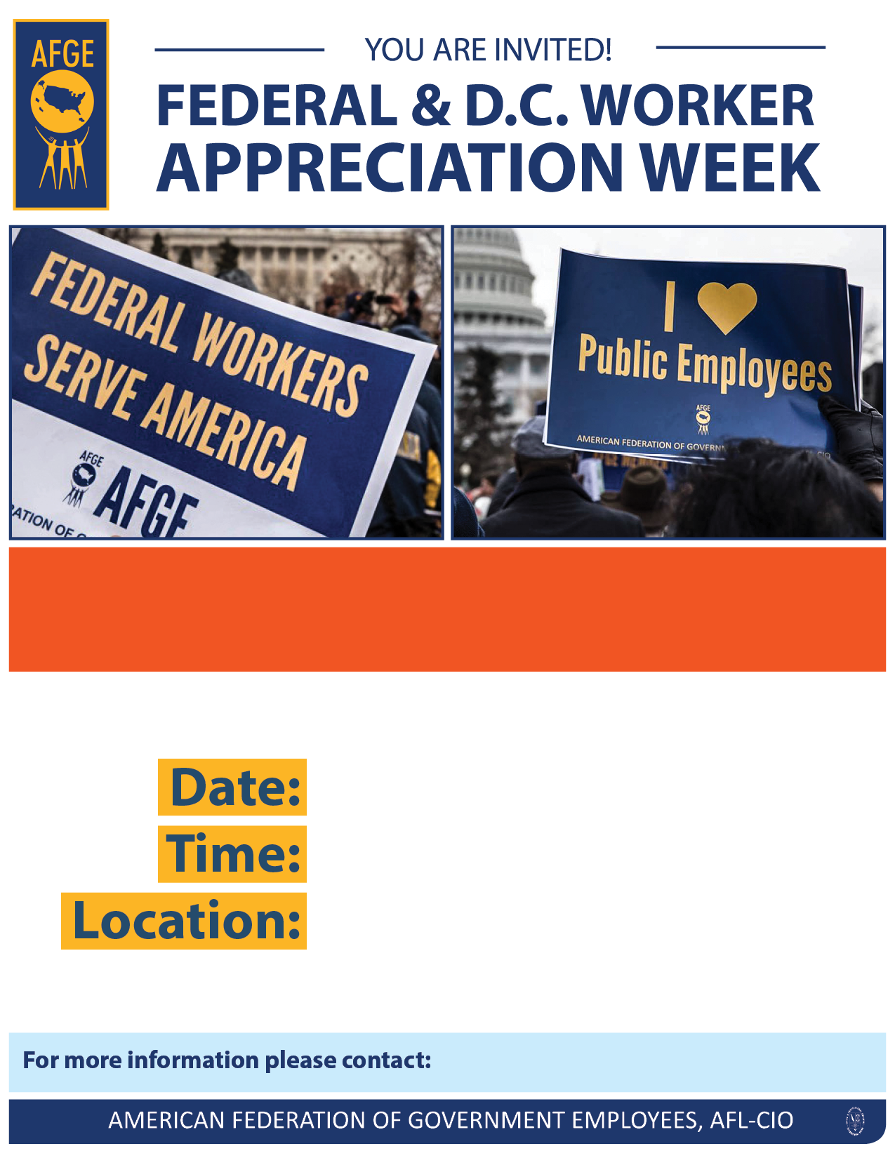

**The work you do to serve the American people is critical in keeping our country moving. That’s why AFGE has declared March 18-22, 2019 as Federal & D.C. Worker Appreciation Week. To celebrate, we are holding a special event – a [Describe Event] with special guest [add any special guests]. [Add any notes about lunch served, etc.]. Can you join us?**

XXXX-XXXX

XXXX-XXXX

XXXXXXXX

XXXX-XXXX

XXXXXX XXXXX @ XXX-XXX-XXXX