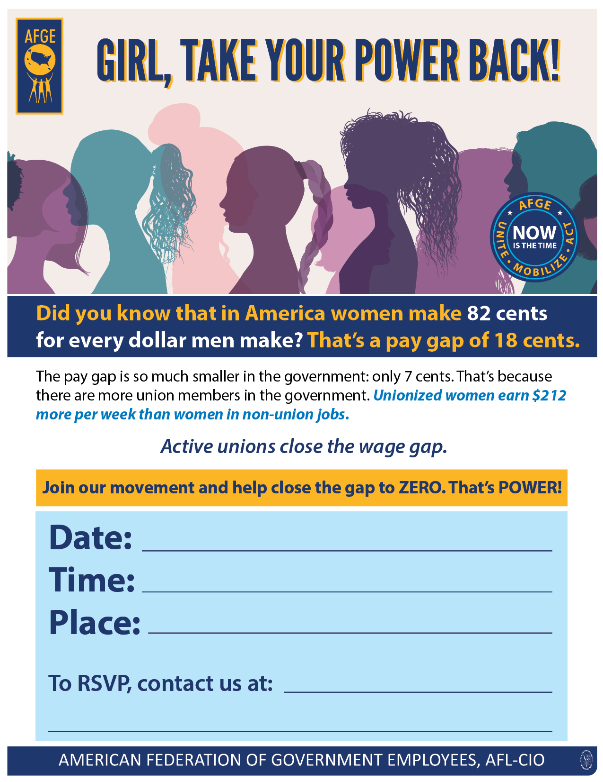

**Monday, June 3 (editable)**

**(editable)**

**(editable)**

**132 Plaza, downtown (editable)**

**3 pm (editable)**

**XXXXXXXXX**